Day 11 – 10 Apr 2024

Docker Intro

Docker is an open-source platform is used to containerized our application or software, using which we can easily build our application and package them with required dependencies to run the application into container and these containers are easily shipped to run on other machine without run time environment.

Docker is an advanced version of virtualization.

Container : run time environment or engine which provide service to run the application.

Docker images : docker image is read only template which is responsible to runt the application.

Virtualization Vs Containerization

VMWare software

Base machine 16 RAM and 1 TB hard disk.

Guest OS -🡪 4GB ram 50 GB memory

10 Guest OS.

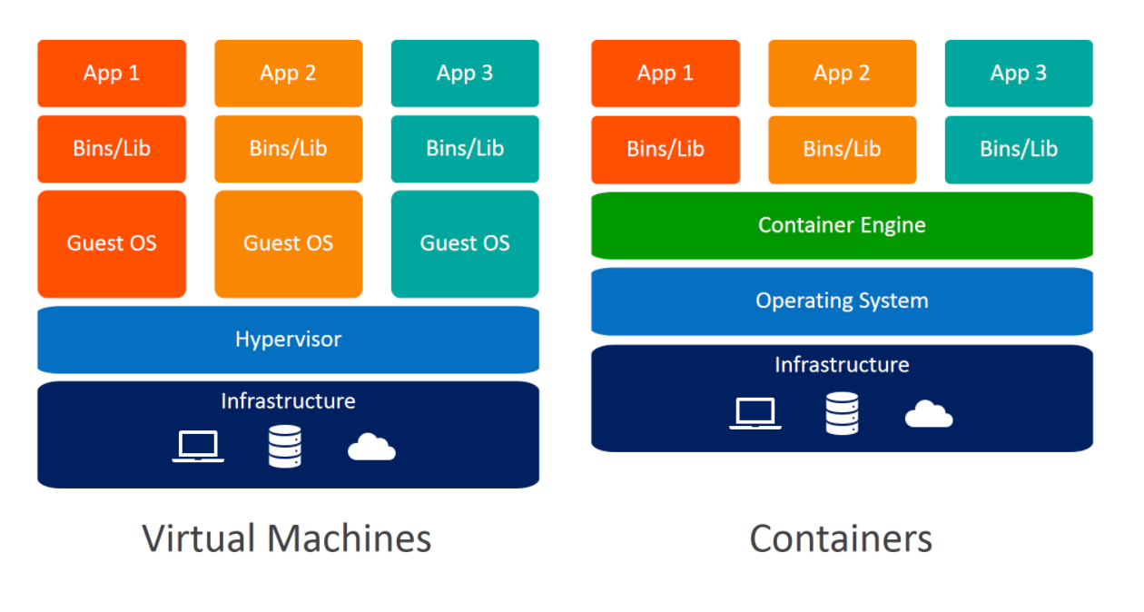

Using Virtualization we can create abstraction version of an OS.

Using Containerization we can create abstract version of an application.

**docker --version**

**docker info**

**docker images**

**docker pull imageName/imageId**

**docker run imageName/imageId**

**docker file : docker file contains set of rules which help to create the image. It is source code for the images.**

**Creating image to display message**

**Dockerfile**

FROM busybox

CMD ["echo","Welcome to Docker image created by akash kale!"]

**docker build -t my-busybox . -f Dockerfile**

**docker images**

**docker run my-busybox**

**creating image to run java program**

**Demo.java**

class Demo {

    public static void main(String[] args) {

        System.out.println("running java program using Docker!");

    }

}

**Dockerfile**

FROM openjdk:11

COPY Demo.java .

RUN javac Demo.java

CMD ["java","Demo"]

**docker build -t my-java . -f Dockerfile**

**docker run my-java**